Maple Hills PTA Newsletter May 2024

For a translatable version, please visit: https://maplehillspta.com/Home
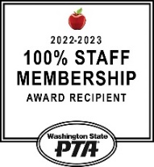
The Chirp!
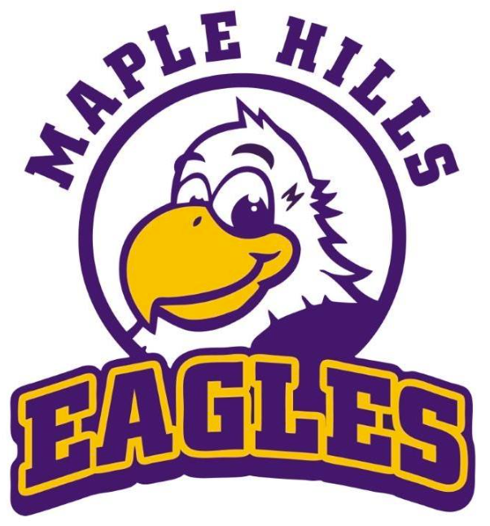
Important Dates
May 3rd
Popcorn Friday
May 5th
Online Eagle Reader Minutes Due
May 6th
Paper Eagle Reader Minutes Due
May 6th – 10th
Staff Appreciation Week
May 10th
Art Walk
May 14th
Eagle Reader Clubhouse
May 16th
Last Eagle Reader Clubhouse
May 17th
Popcorn Friday
May 27th
Memorial Day – No School
May 31st
Pizza BINGO Fundraiser

Dear Families:
We wanted to share some of the incredible achievements of our PTA and its dedicated volunteers in just 8 months!
We're thrilled to report that we've achieved a remarkable 100% membership again this school year - one PTA member for each child at our school, showing unwavering support from our community.
With over 280 volunteers passionately contributing their time and effort, we've made a profound impact together.
Throughout this journey, we've orchestrated 50 successful events, including 7 fantastic fundraising initiatives, rallying support and resources for our school's diverse needs. We're especially proud to announce 100% Art Docent Coverage, ensuring every classroom enjoys the enrichment of artistic education, a milestone we haven't reached in quite some time.
Our commitment to literacy shines through our 7 Eagle Reader Clubs, fostering a love for reading among our students. Additionally, we've introduced our inaugural "The Chip" paper newsletter, delivering updates and insights directly to our families' purple folders, enhancing communication and community engagement.
Beyond these accomplishments, our focused fundraising efforts have provided essential support to our staff and community. From supplying an emergency response cart for the nurse's office to collecting gas cards and supporting the Holiday Needs Drive for the counselor's office, we've shown our dedication to the well-being of our school community.
As we reflect on these achievements, we're filled with gratitude and excitement for the positive impact we've made together. Thank you to all our members, volunteers, and supporters for your unwavering dedication and commitment. The year is not over yet! Here's to many more accomplishments ahead!
~Maple Hills PTA
🍕Pizza Bingo🍕  is on May 31st at Maple Hills Elementary! We're seeking prize donations of new toys, games, books, and unused auction items. Gently used toys are also appreciated.  For inquiries, please contact yaz.armstrong@gmail.com.  See you there! 🍕🎉  🌟✏️ Calling all families and students! ✏️🌟  From May 6th to 10th, we're rolling out the red carpet for our outstanding teachers and staff during School Staff Appreciation Week. Each day, we'll have a unique way to show our gratitude and admiration for their hard work and dedication. Stay tuned for updates on how you can join us in honoring these exceptional individuals!  🎉⚾ Step up to the plate and support our school's PTA fundraiser! ⚾🎉 Join us at the Tacoma Rainiers Baseball Game on SATURDAY, June 8th at 6:05 pm for an evening of baseball excitement. Buy your tickets today and make it a day of family fun! Plus, if we sell enough tickets, we'll score a visit from Rhubarb the Reindeer right here at our school! Stay tuned for ticket sales information and let's make this fundraiser a grand slam! |  | 🎉🎨 ART WALK 🎨🎉  It's time to celebrate our young artists!  Join us at Maple Hills on Friday, May 10th from 5:30 to 7:00 pm for our annual PTA Art Walk. Each grade will proudly present their artwork from the past year, showcasing their creativity and dedication. Plus, there will be exciting projects for all ages to enjoy together.  Don't miss this chance to support our students and immerse yourself in the world of art!

Eagle Reader Minutes Reminder!
Remember to update
your student’s
Eagle Reader minutes.
Online May 5th and paper May 6th.
Students will earn a free book
the following month.
Your student's minutes can
be recorded online at:
https://maplehillspta.com/Read/eaglereader
or scan the QR code below.
Membership!
Thank you to our amazing community for helping us to achieve 100% PTA membership for the 2024-2025 School Year!

Spring Book Fair 2024 results
Scholastic Dollars Earned (balance to spend with Scholastic): $7,598.62. This equates to 625 Books to fund the next 3 Eagle Reader Clubhouses (averaging 210 Books per Eagle Reader Clubhouse)
Round Up Fundraiser: $98.88 = 8 books
Books donated to the school Library: $197.71 = 16 Books
Books donated to School Counselor: $217.18 = 18 Books

Stay in the know with our weekly emails via our E-News. It includes important dates, events, and school programs, and more.
Hey Watch D.O.G.S.! We have several volunteer slots that need filling. Sign Up Here: https://maplehillspta.com/Page/PTA/Watch%20DOGS
